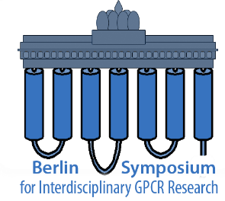
1. Berlin Interdisciplinary Symposium
for Young GPCR Researchers
12th April 2018 10:30–18:30
Freie Universität Berlin, Institute of Pharmacy
Name of participating author:
Institution:
E-mail address:
Abstract title
Authors
Affiliations

Abstract text (Arial 11pt, max 300 word, please do not exceed this page)

